Disaster Relief Workforce Emergency Fund
Distributed by SCP Disaster Relief Revolving Loan Fund

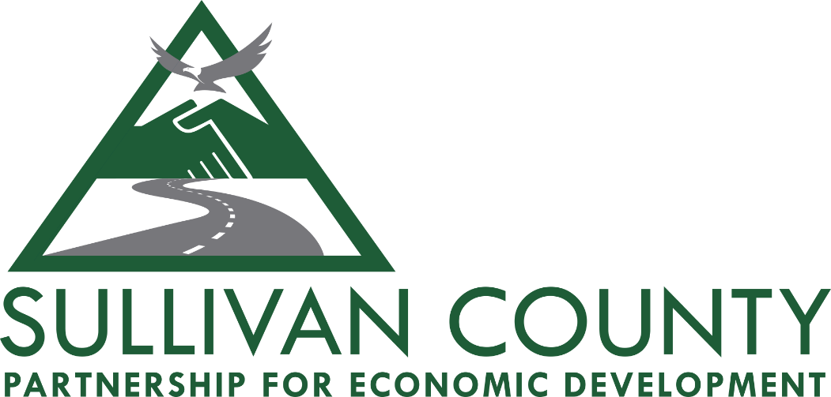

Partnership for Economic Development in Sullivan County
196 Bridgeville Road, Suite 2
Monticello, NY 12701
www.scpartnership.com

Updated Version: March 2020

Administered by Sullivan County Partnership for Economic Development

Disaster Relief Workforce Emergency Fund Guidelines
Objectives
The primary objective of the DRWE Fund, distributed by SCP Disaster Relief Revolving Loan Fund, is to assist existing business owners whose business establishment has experienced short-term interruption in business income due to the Novel Coronavirus/(COVID-19) health emergency. The DRWE Fund will make financing available to business owners to solve immediate business needs (i.e. covering payroll demands, insurance payments, etc.) and other costs deemed acceptable by the Revolving Loan Committee.
Notes:
*A total of 10 loans exist, after all applications are submitted the Partnership staff will review and distribute loans to eligible applicants.
*The Disaster Relief Workforce Emergency Fund will be distributed through the SCP Disaster Relief Revolving Loan Fund. The DRR Loan Fund exists due to a donation made by a private sector donor.

Application Review Factors
Applicants must show they are experiencing financial hardship due to the Covid-19 health emergency.
DRWE loans will be made up to a maximum of $5,000.
All companies applying for DRWE financing must be 75% owned by U.S. citizens and permanent legal residents.
Rates and Terms of Approved Loans:
The rate will be set at one percent and all application and closing fees are waived. Terms will be eight quarterly payments of principal and interest beginning one year after signing. Rates and terms beyond these limits may be set at the discretion of the Revolving Loan Fund Committee.
The Partnership staff will monitor the status of the loan as it is deemed necessary by the Revolving Loan Fund Committee to ensure that repayment is made in a timely manner.
If any of the loan conditions referenced in these guidelines are not met, the Revolving Loan Fund Committee may impose a penalty interest rate on the remaining balance of the loan, equal to prime plus 5% retroactive to the date the last scheduled payment was made.
Fees:
Closing/Application fees are not applicable to DRWE Fund financing.

Eligibility Criteria
Eligible Applicants:
- Applicants may be sole proprietors, partnerships or corporations, with a physical business address or incorporation address in Sullivan County.
- Applicant businesses with 10 employees or less will be prioritized; eligibility of businesses with more than 10 employees will be at the discretion of the Revolving Loan Committee.
- Applicants must show they are experiencing financial hardship due to the Covid-19 health emergency, by providing written documentation explaining need and use of funds.
- Applicants must prove ability to repay DRWE loan by providing the following:
  - Copy of 2 years business/personal taxes.
  - Proof of business loans and repayments within the last 5 years, if applicable.
- Applicant must have a “Fair” credit score, credit report must be provided by applicant.
- Applicant must have been in business for at least 2 years.

Applicant Requirement(s):
A personal guarantee of all principals who own 20% or more of the business.
Eligible projects are businesses affected by CDC/NYS recommendations and Executive Actions by Governor Cuomo regarding the Novel Coronavirus/(COVID-19) health emergency.
Ineligible projects are businesses not affected by the Novel Coronavirus/(COVID-19) health emergency.
Eligible Uses of DRWE Financing:
Loans under the DRWE Fund may be made for up to $5,000. These funds may be used to solve immediate business needs (i.e. covering payroll demands, insurance payments, etc.) and other costs deemed acceptable by the Revolving Loan Committee.
Ineligible Uses of DRWE Financing:
Loans under the DRWE Fund may not be used to pay off other debts owed.
APPLICATION PROCESSING:
Applications shall be submitted in the format specified by the Partnership Revolving Loan Fund Committee. Such applications shall be submitted to the Partnership for Economic Development, 196 Bridgeville Road, Monticello, New York 12701. Once received, the application will be reviewed for completion and to ensure that all minimum eligibility criteria are met. Partnership staff shall then review the application and will make recommendations to the Revolving Loan Fund Committee concerning application approval or denial. Such staff review shall generally be completed within two weeks of receipt of the completed application.
The Revolving Loan Fund Committee shall then meet at an expedited schedule, given the gravity of current circumstances, to review the application and recommendations of the Partnership staff and render a decision on the loan request. The decision of the Revolving Loan Fund Committee as outlined in a review process above shall generally be made as soon as possible in order to meet the needs of the applicant. Decisions will be expedited sooner if conditions are met and the nature of the request is critical to the daily conduct of business by the applicant.

